My IIM View

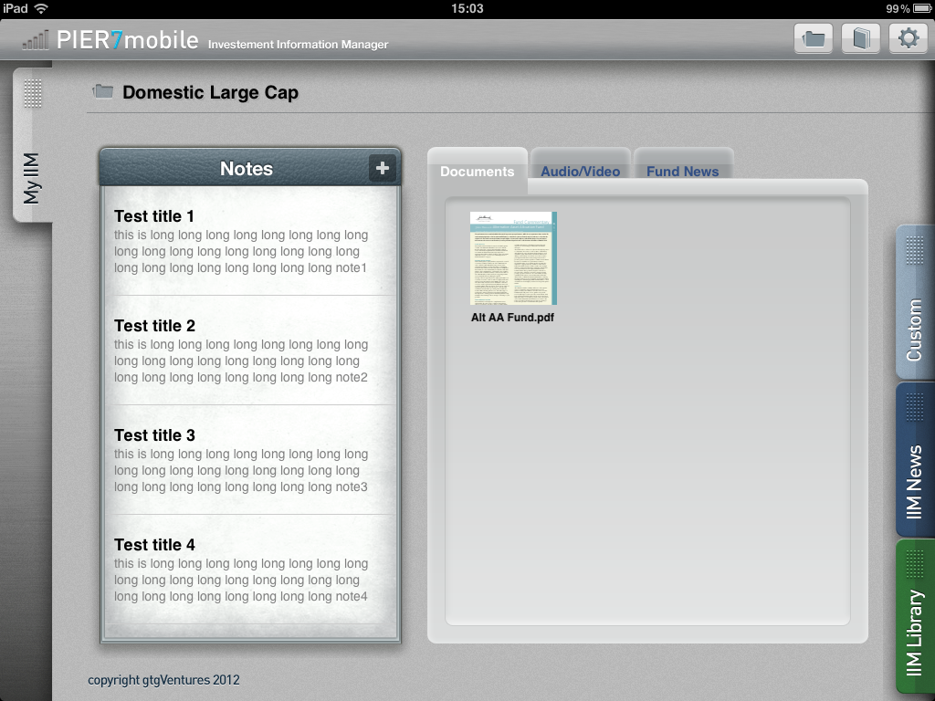

List folders

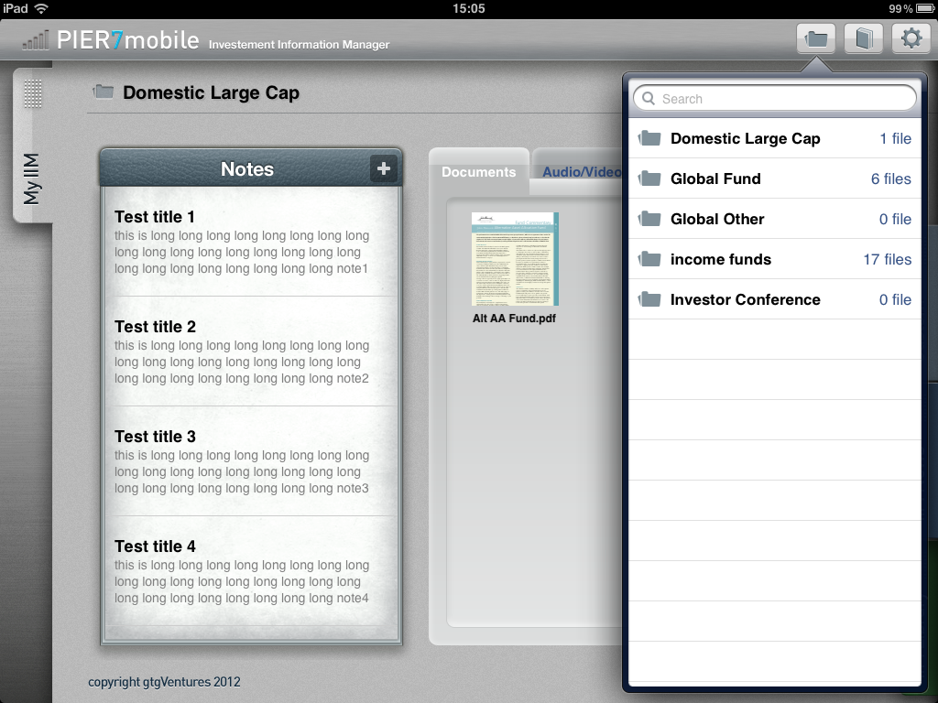

1. Tap  to list local folders
2. Tap the folder name to switch the content (Notes/Documents/Media) in My IIM view

Download View

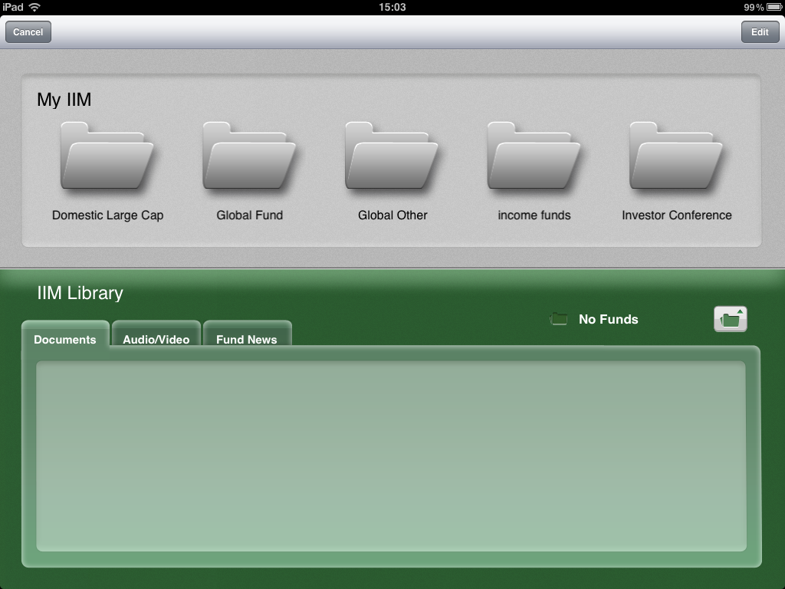

1. Tap  to switch to Download view
2. User can add/remove My IIM folder in this view
3. User can drag remote files (IIM Library) from box.net to My IIM folders
4. Tap “Edit” to manage My IIM folders
5. Tap “Cancel” to back

Create folder

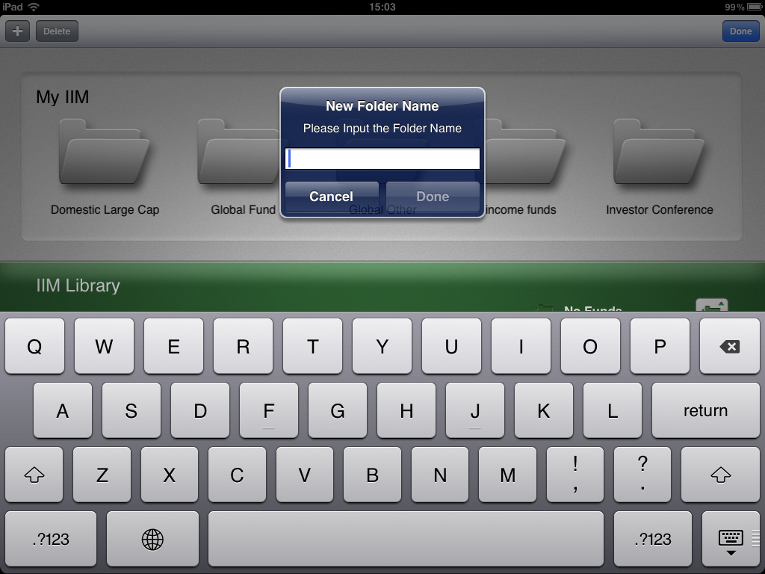

Delete folder

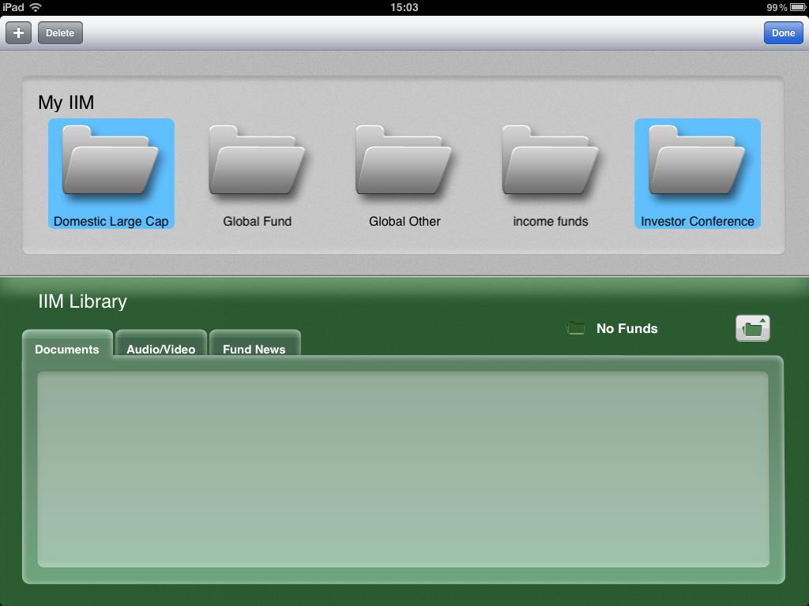

Switch IIM Library folder

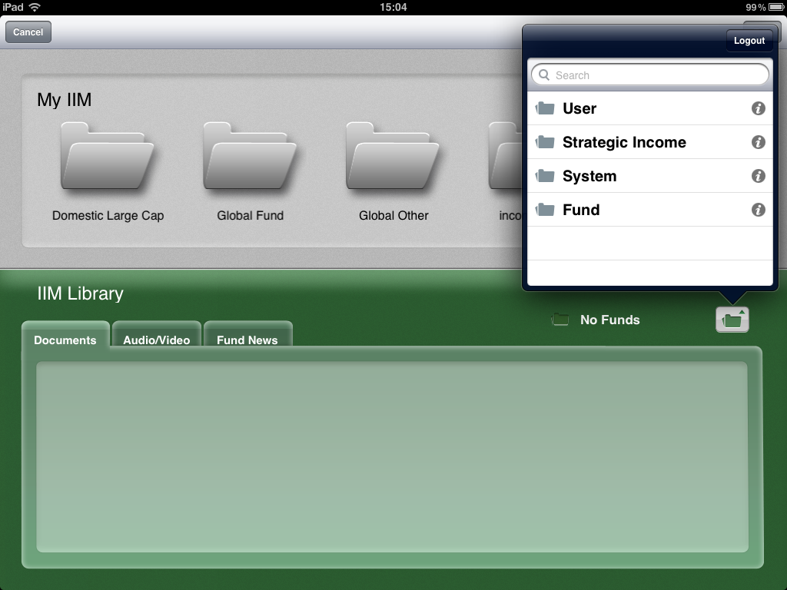

Drag files from remote to local

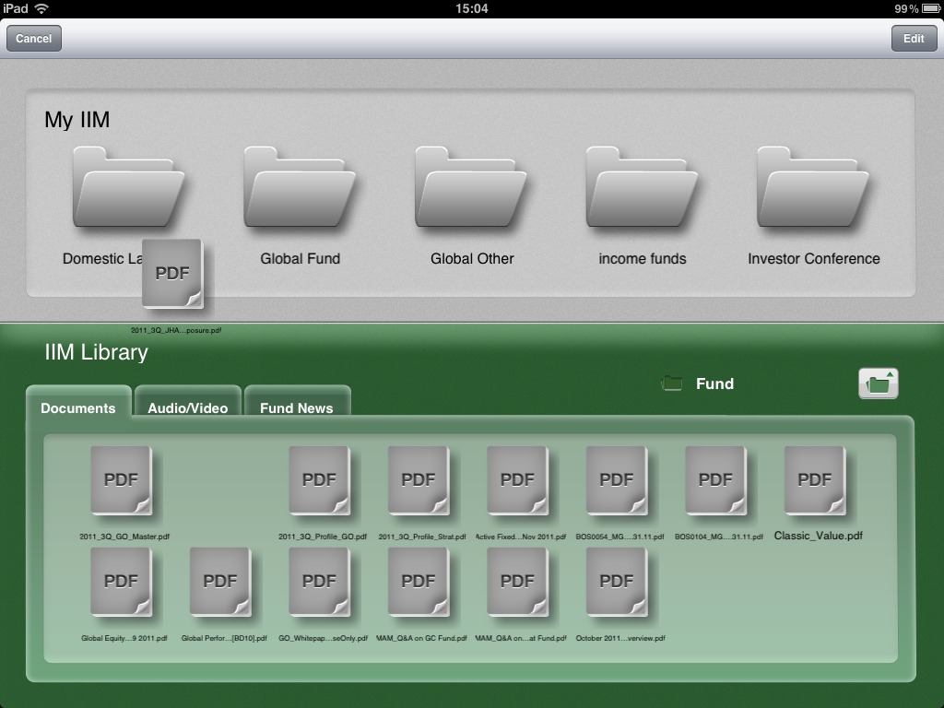

1. The download process is working as backend thread
2. There is no new file icon in My IIM folder before the download is finished
3. User cannot do any operation for remote files